NAME: RAUNAK SHARAMA

ID: 2018A3PS0377P

SECTION - 1

**TASK-1**

clc

clear all

close all

N = 10^6;

data = randi([0 1],1,N);

data_transmission = 2*data - 1;

data_received = zeros(1,N);

Noise_db = -150;

BW = 100;

noise_power = 10^((Noise_db/10)-3)*BW;

Noise_standard_deviation = sqrt(noise_power);

Noise = Noise_standard_deviation*randn(size(data));

%Noise = Noise';

P = 1e-24;

signal_power = [];

ber_function = [];

bit_error = [];

while P <= 1e-12

transmission = sqrt(P)*data_transmission;

received = transmission + Noise;

for i = 1:N

if received(i)>=0

data_received(i) = 1;

else

data_received(i) = 0;

end

end

[dummy,ratio] = biterr(data_received,data);

bit_error = [bit_error ratio];

signal_power = [signal_power 10*log10(P)];

ber_function = [ber_function

qfunc(sqrt(P/noise_power))];

P = P*10;

end

scatterplot(transmission,[],[]);

title('Transmitted Signal')

scatterplot(received,[],[]);

title('received Signal')

figure(3)

plot(signal_power,bit_error)

hold on

plot(signal_power,ber_function)

legend('Average BER','Theoretical BER')

xlabel('Signal Power in dB')

ylabel('BER Ratio')

title('BER Vs Signal Power)');

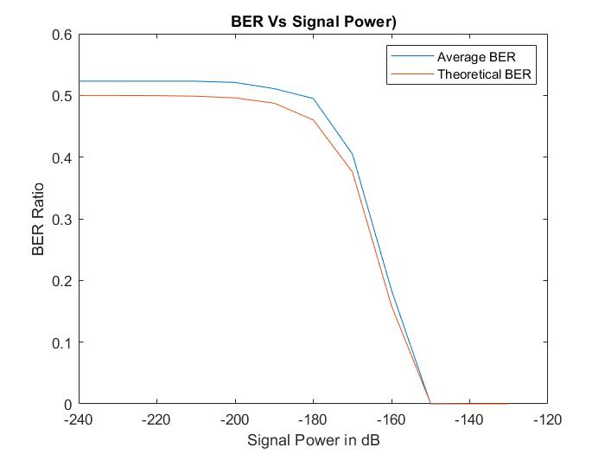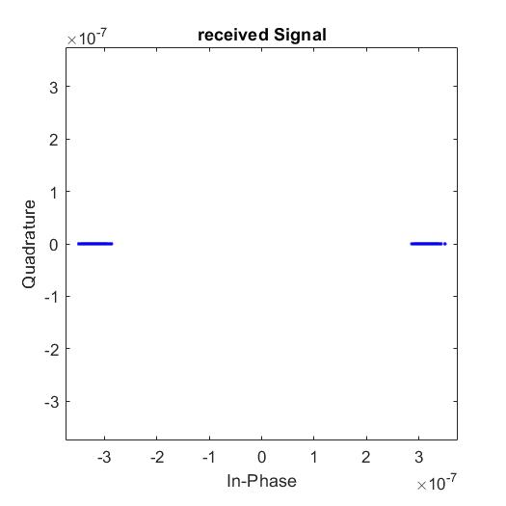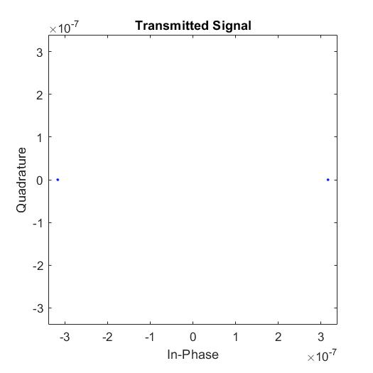

**Task-2**

clc

clear all

close all

N=10^6;

alpha = 1e-3;

data = randi([0 1],1,N);

data_transmission = 2*data - 1;

data_received = zeros(1,N);

Noise_db = -150;

BW = 100;

noise_power = 10^((Noise_db/10)-3)*BW;

Noise_standard_deviation = sqrt(noise_power);

Noise = Noise_standard_deviation*randn(size(data));

%Noise = Noise';

P = 1e-24;

signal_power = [];

ber_function = [];

bit_error = [];

while P <= 1e-8

transmission = alpha*sqrt(P)*data_transmission;

received = transmission + Noise;

for i = 1:N

if received(i)>=0

data_received(i) = 1;

else

data_received(i) = 0;

end

end

[dummy,ratio] = biterr(data_received,data);

bit_error = [bit_error ratio];

signal_power = [signal_power 10*log10(P)];

ber_function = [ber_function

qfunc(sqrt(P/noise_power))];

P = P*10;

end

scatterplot(transmission,[],[]);

title('Transmitted Signal')

scatterplot(received,[],[]);

title('received Signal')

figure(3)

plot(signal_power,bit_error)

hold on

plot(signal_power,ber_function)

legend('Average BER','Theoretical BER')

xlabel('Signal Power in dB')

ylabel('BER Ratio')

title('BER Vs Signal Power, with channel coefficient of 10^(-3)');

